Dear

**Re: GDPR Compliance**

I confirm that House Martins Care Limited is GDPR compliant and that there are processes in place to ensure ongoing compliance through regular audit and procedural check. I confirm that the organisation is registered with the Information Commissioners Office.

I confirm that any personal / sensitive data held on behalf of yourself is held in compliance with the GDPR regulations, held securely and used only in relation to the agreement in place to provide services. Any data held will be destroyed securely and in line with the required retention arrangements under GDPR.

Yours sincerely

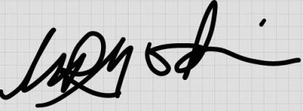

On behalf of House Martins Care Ltd

Name: Geoff Godwin

Position: Registered Manager

Date: 21 May 2018